VnV
Mini Project / PLP Document

Asset Management System
(AMS)

Document Control

Reference No:
Security Classification: | iGATE Internal
Issue Date:
Author(s): | Name |  | Title
Author(s): | Shrilata Tavargeri |  | Sr. Training Specialist
Reviewer(s): | Name |  | Title
Reviewer(s): | iLEARN Seniors Team |  | Sr. Faculty, Sr. Managers
Issuer(s): | Name |  | Title
Issuer(s): | Dinesh Anantwar |  | Sr. Manager
Issuer Signature(s):
Distribution: | Name |  | Title
Distribution: | iLEARN Team, PPPs |  | All Designations in iLEARN
Document History: | Date | Revision | Change
Document History: | Nov 22, 10 | 0.01D | Initial draft
Document History: | Nov 24, 10 | 0.02D | Review comments incorporated

Table of Contents
1 Introduction 4
1.1 Setup Checklist for Mini Project 4
1.2 Instructions 4
2 Problem Statement 5
2.1 Objective 5
2.2 Abstract of the project 5
2.3 Functional components of the project 5
2.4 Guidelines on the functionality to be TESTED: 6
2.5 Evaluation and assessment parameters: 11
2.5.1. Guidelines on the functionality 11
2.5.1. Evaluation Policy 12

Introduction

This document outlines a mini project for the V&V LOT. The project is to test an online Asset Management System (AMS).. This document contains the work flow of the system and gives guidelines on how to test the functionality gradually in each of the course modules of the V&V LOT.

Setup Checklist for Mini Project
Minimum System Requirements
- Intel Pentium 90 or higher (P166 recommended)
- Microsoft Windows 95, 98, or NT 4.0, 2k, XP.
- Memory: 32MB of RAM (64MB or more recommended)
- Internet Explorer 6.0 or higher
- MicroSoft Word and Excel 2003 or higher

Instructions
- The test cases should follow the test case standards.
- Create a directory by your name in drive D. In this directory, create a subdirectory MiniProject<Groupcode>. Store your Project here.Every document related to your mini project should be available in the same directory.
- You can refer to your course material.
- You have to follow the flow while doing the mini project, like Requirement Itemization -> Use cases -> Use case level test cases -> Form level test cases -> Filed level Test cases.

Problem Statement

Objective
Testing an online Asset Management System (AMS).

Abstract of the project
This project is aimed at developing Online Asset Management System. This is an Intranet based application that can be accessed throughout the organization and this is a web based application that can be accessed over the web. This system can be used to search for an asset based on search condition, assign a hardware asset to/from an employee based on request, insert new asset details, modify an existing asset details and display all asset allocation request details. This is an integrated system that contains both the user (Manager) component and the Admin component.

Test the Application for the above requirement using the following Project link:
http://ndafile:8081/AssetManagementSystem_Spring/index.html

Use following user credentials to access above given project link.

Username | Password | Role
Manager | Manager | User(Manager)

Functional components of the project
Following is a list of functionalities of the system. Wherever, the description of functionality is not adequate, you can make appropriate assumptions and proceed.

There are two categories of people who would access the system viz. User (Manager) & Admin. Each one of them would have some exclusive privileges (for e.g. Managers can just raise a request for allocation/release of an asset for his/her team member on behalf of them.)

- Managers should be able to

  - Login to the system using his/her credentials
  - Raise a request for allocation of asset to an employee, by filling up the asset requisition form that auto generates the asset request ID.
  - View the status of request, based on the asset request ID

- The administrators should be able to

  - Login into the system using his/her credentials
  - Include new asset/modify asset details from the inventory.
  - Approve/Reject a request on the basis of the details of the request raised. If raised request is approved, then allocate asset to an employee and change request status as ‘Allocated’.
  - Generate various reports like:
    - View List of assets available in an organization based on category:
      - Allocated Assets
      - Unallocated Assets
    - Also export the assert details data into an excel sheet.

Guidelines on the functionality to be TESTED:
- Tables

    - User_Master: This will contain the list of valid users.
    - Department: This contains the list of departments available in the organization.
    - Employee: This will contain the details of an employee who have joined in an organization.
    - Asset: This will contain the details of available hardware asset in an organization
    - Asset_Allocation: This will contain the details of asset allocated for an employee.

- The structure of the above listed tables is as follows:

    - User_Master: UserId VARCHAR2(6), UserName VARCHAR2(15), UserPassword VARCHAR2(50), UserType VARCHAR2(10)
For Admin, and User (Manager), assume that the users are already added to the system.

    - Department: Dept_ID int, Dept_Name VARCHAR2(50)

    - Employee: Empno Number(6), Ename Varchar2(25), job Varchar2(50), mgr number(4), hiredate date, Dept_ID number

    - Asset: AssetId Number, AssetName Varchar2(25), AssetDes Varchar2(25), Quantity Number, Status Varchar2(15)

    - Asset_Allocation: AllocationId Number, AssetId Number, Empno Number, Allocation_date Date, Release_date Date

The functionality and components to be tested :

- Application

- Requirement for the application:
i.Home page screen: Home page for the online AMS which provides a link for the login page.

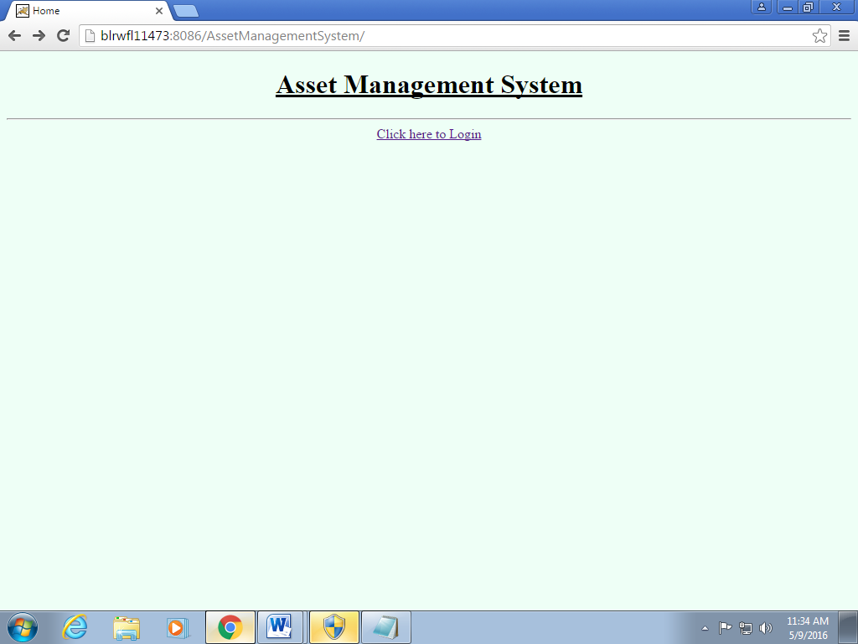

ii.Login Screen: Allows the valid user or amount to logon to the system and display the Main option screen.
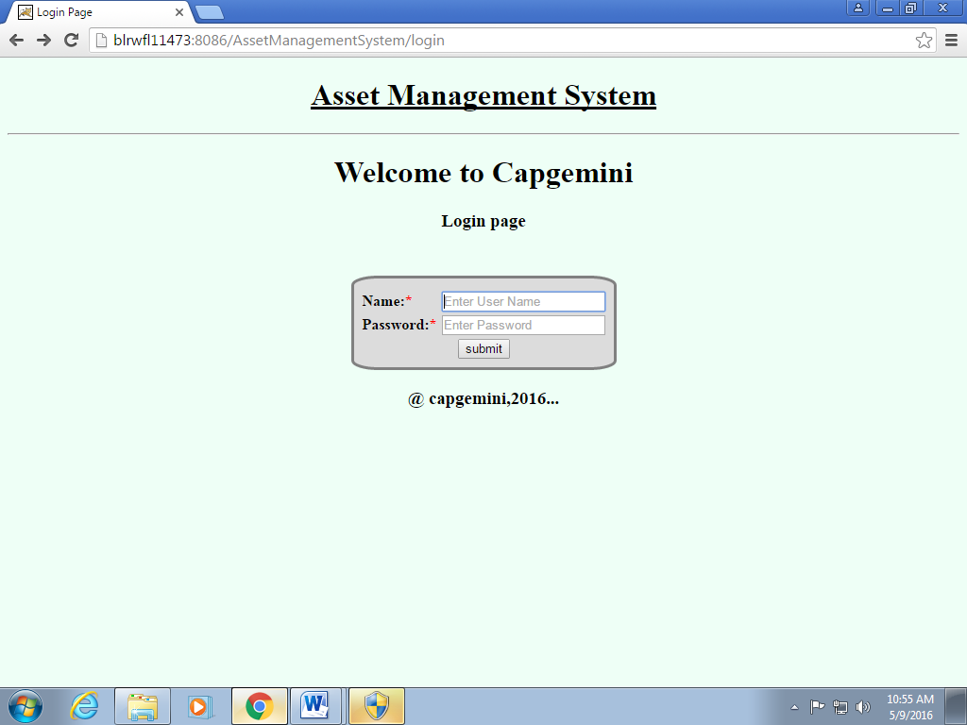
iii.View AMS screen: For all the users, this screen shows the links for raise request and view status.

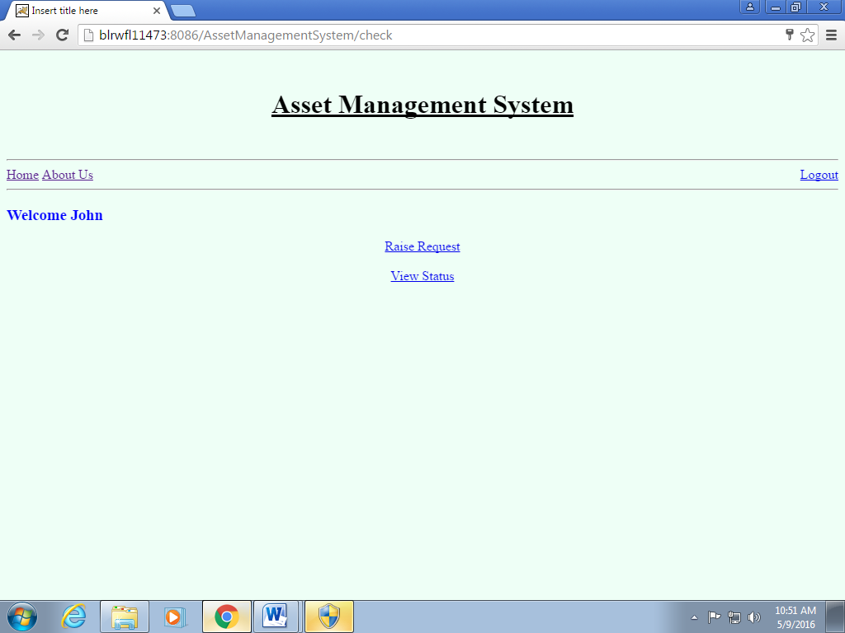

iii.Raise request screen:This screen provides the fields that has to be filled to raise request for a particular asset.
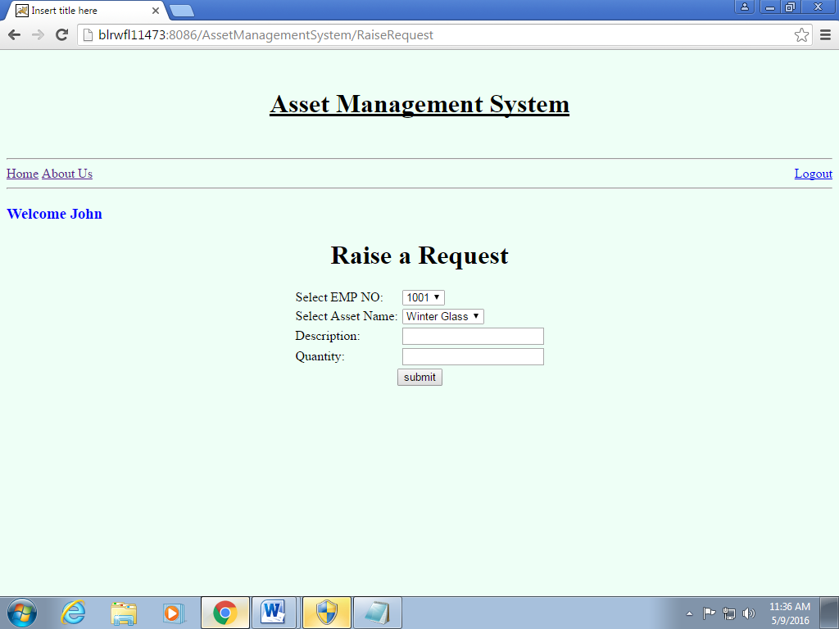

iv.View status screen: This screen provides the status of the raised request for asset.
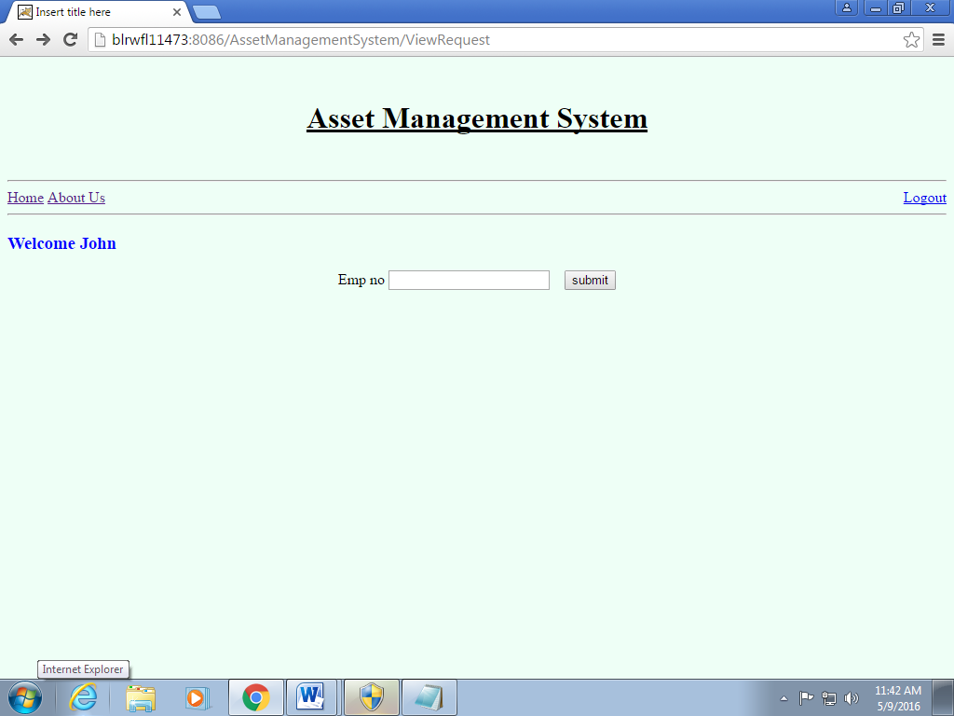

V.AMS page for Admin: This screen provides links for add/modify asset,view request,Approve reject request,export data.
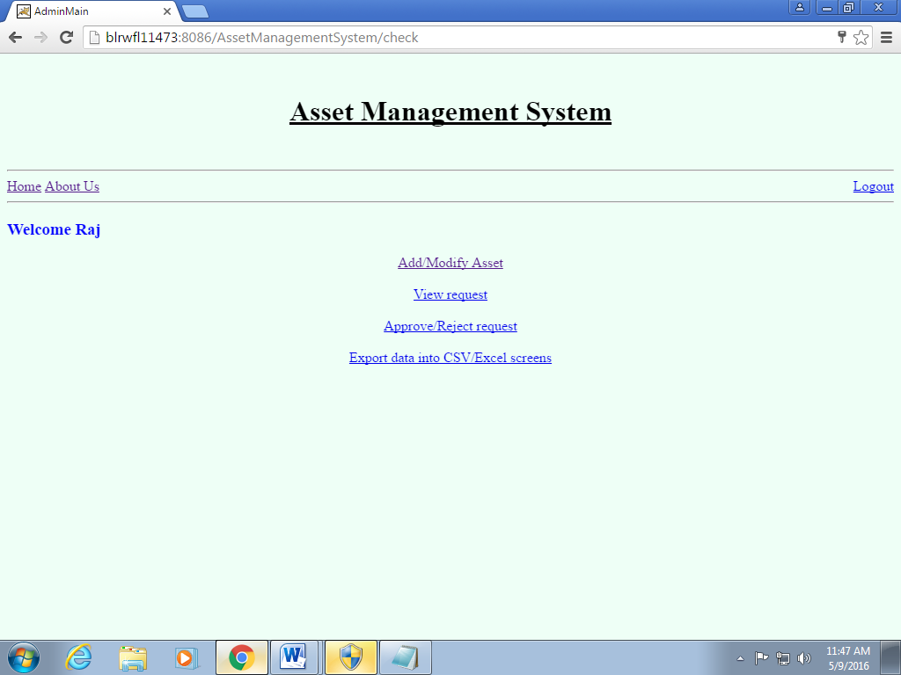

vi.Add/modify page:provides links to add,modify,delete asset.

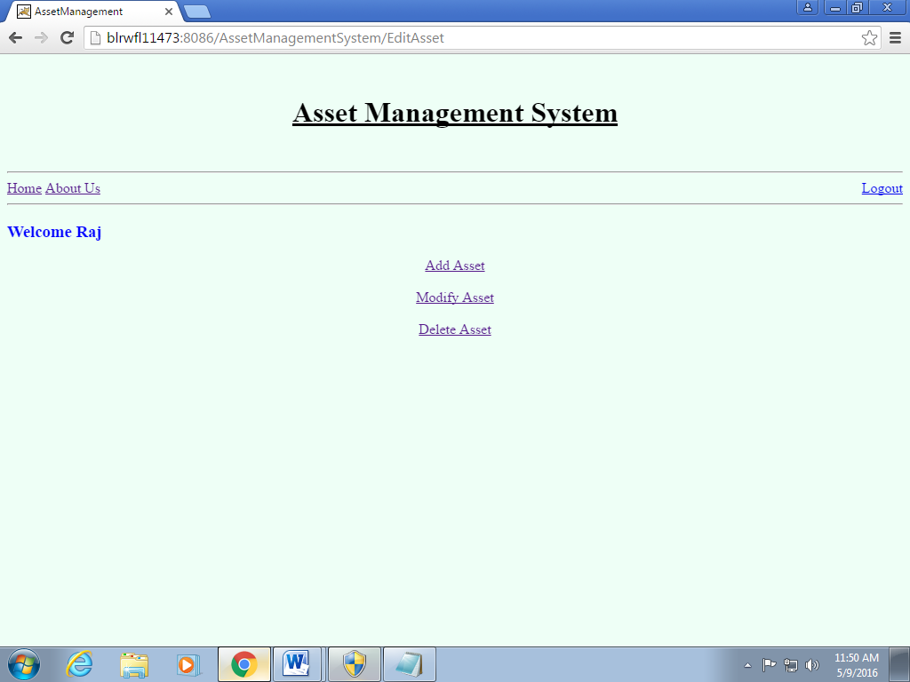

vii.Add asset : Allows admin to add new asset.
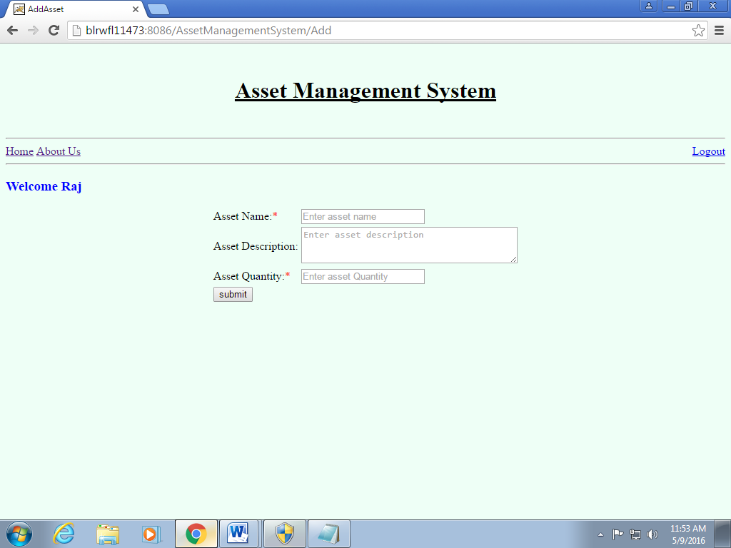

viii.Modify Asset: Allows admin to modify the existing asset.
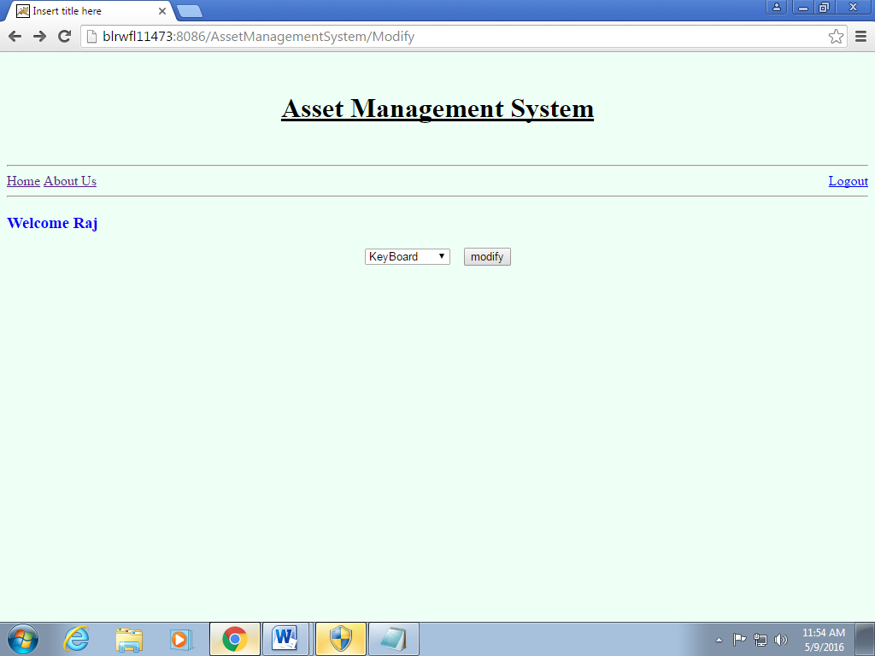

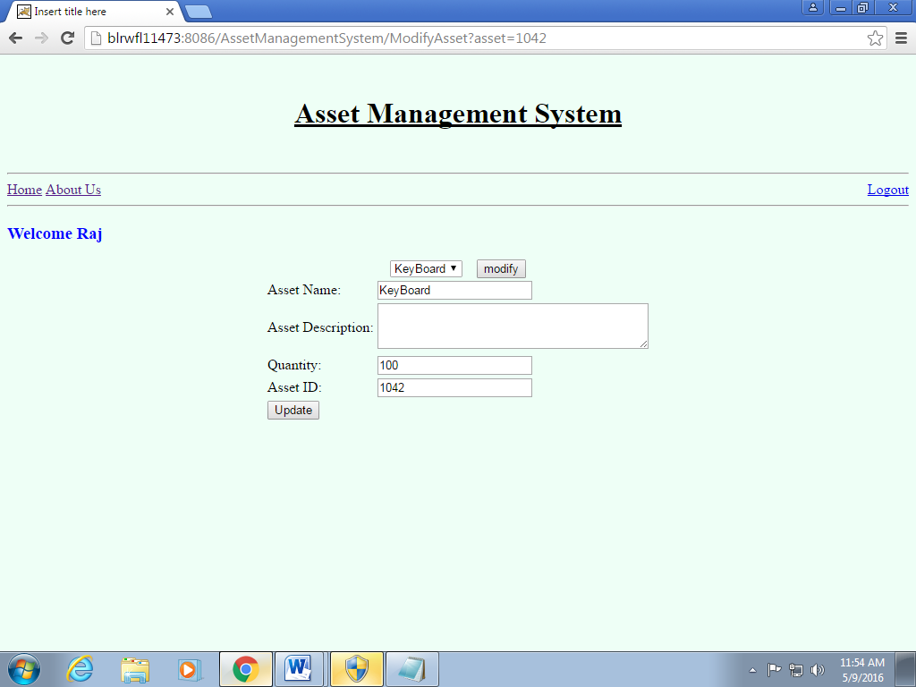

ix.Delete Asset: Allows admin to delete an existing asset
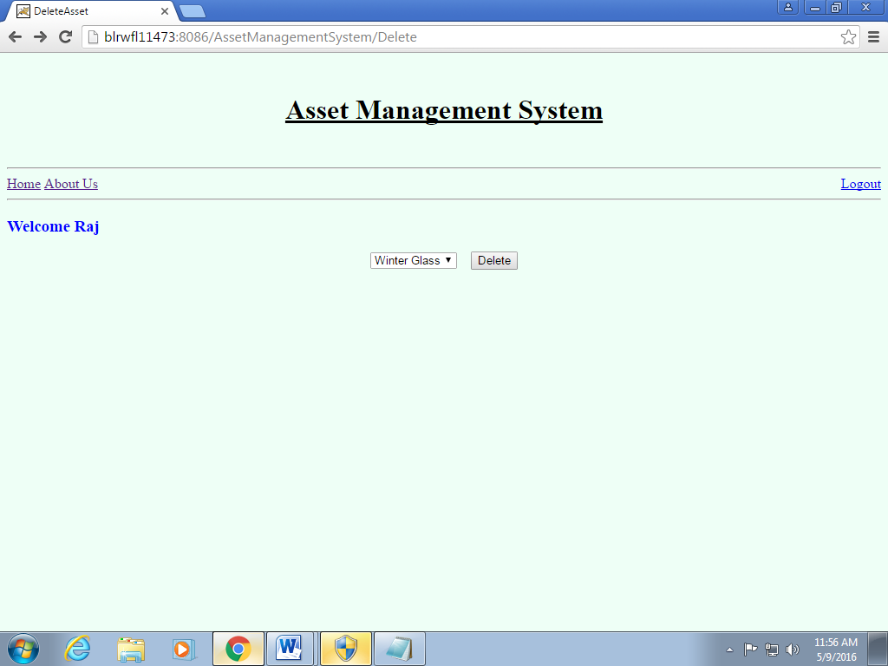

x.View request:allows admin to view the status of the raised request.

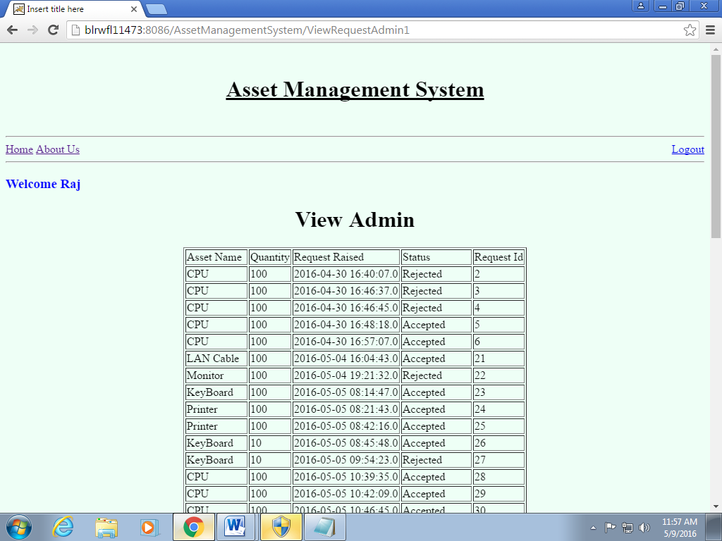

xi.Approve/Reject request: Allows the admin to accept or deny the raised request.

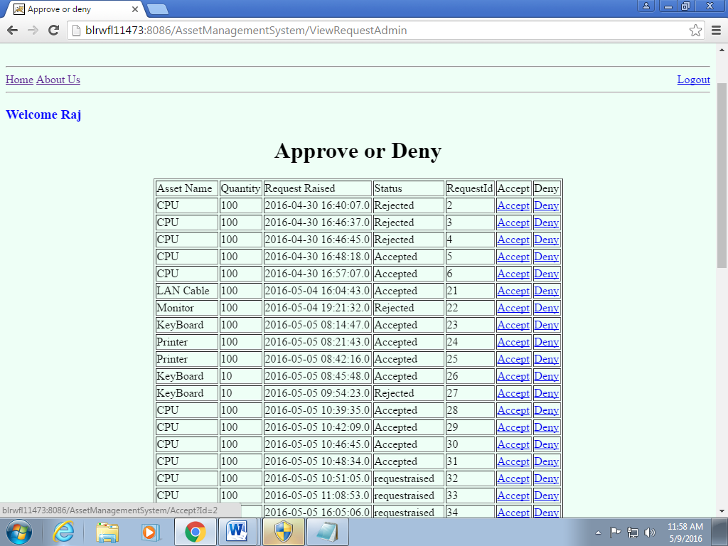

xii.Export data into CSV/Excel Sheet : Allows user to export data into excel sheet.

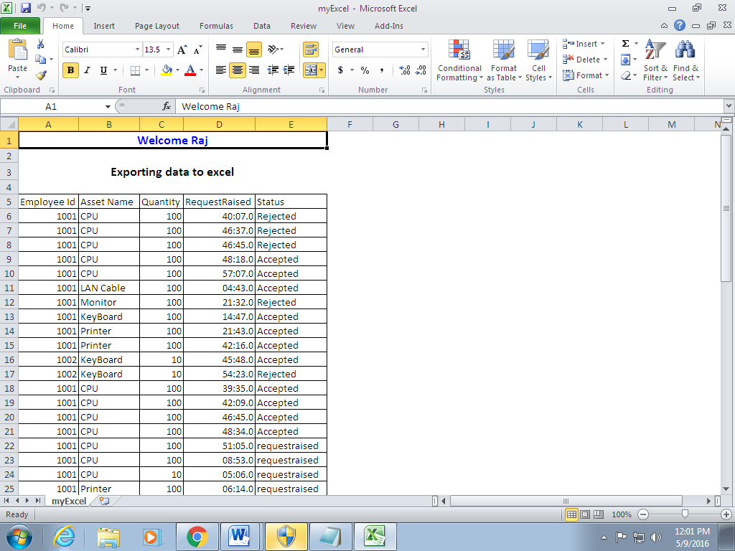

- Test all other screens and links that appear in the application for admin, Employee and Customer.

- Test the business components for the following functionality:
- User verification: (on Login) This component will verify if the user who is trying to access the system is a valid user. This verification is as against the valid users listed in the users table.
- Add/Delete/Modify: This component will allow the admin to add new Assets, update and delete existing Assets.

Evaluation and assessment parameters:
The participants need to do Requirement Itemization and to develop Use case, Scenario matrix and test cases for the Asset Management System using TBA template and defect report while test execution.

Guidelines on the functionality
Form a group of 5 people. One person will be group leader will divide the work among the group members.

Evaluation Policy
Sr. No | Marks | Project Execution
 | 100 | Evaluation shall be done after the DFDR course is over. Participants shall submit the sheet along with V&V DFDR assignments.

Following points will be considered for giving marks:

Sr. No | Points to be considered | Marks
 | Writing test cases in appropriate sheets. | 30
 | Defect report creation | 20
 | Proper and concise explanation of test cases and Input data | 30
 | Format of the sheet | 10
 | Complete solution | 10

